Hedge Fund_Final Exam – Review Notes _2
Date: 21 March 2026

Review Slides Review
1.
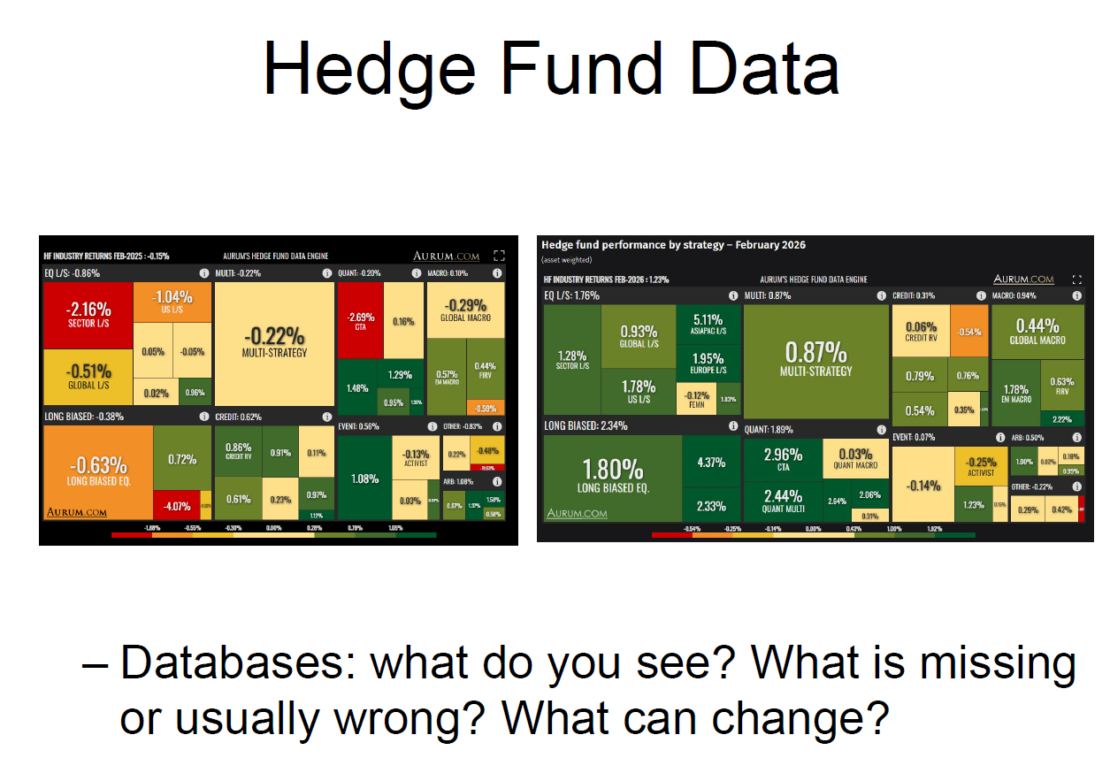
https://www.aurum.com/hedge-fund-performance/
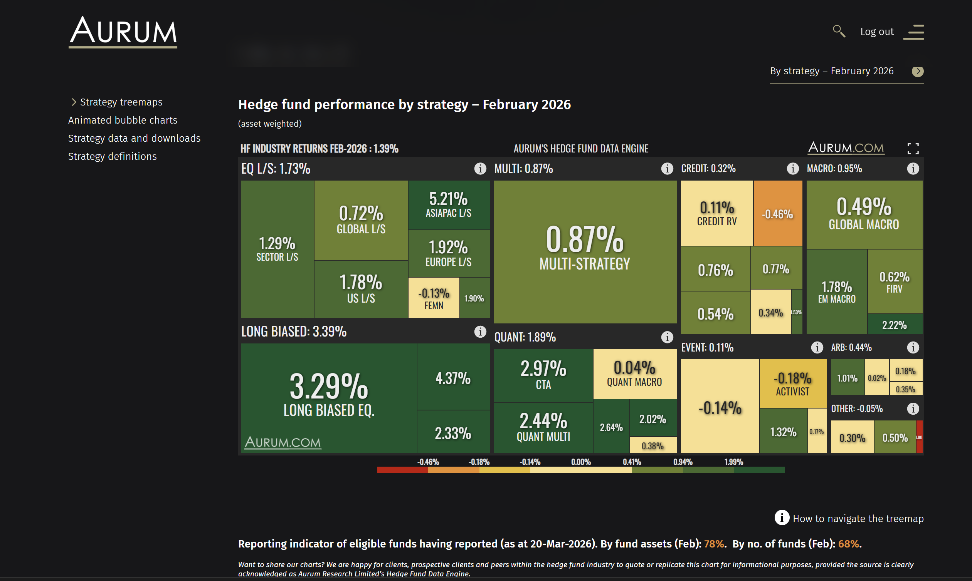
Reporting indicator of eligible funds having reported (as at 20-Mar-2026). By fund assets (Feb): 78%. By no. of funds (Feb): 68%.
Source: Aurum’s proprietary Hedge Fund Data Engine database containing data on around 3,100 active hedge funds representing around $3.4 trillion of assets as at December 2025. Information in the database is derived from multiple sources including Aurum’s own research, regulatory filings, public registers and other database providers. Performance is asset weighted. Box size reflects the AUM of the hedge fund industry, as tracked by Aurum. See the disclaimer and strategy definition for further details. This webpage and its contents do not constitute an offer to sell or a solicitation of an offer to buy or endorsement of any interest in any hedge fund strategy. An investment in a hedge fund should be considered a speculative investment. Past performance is no guarantee of future returns.

#1.1 Summary
What the Aurum Charts Show
The treemaps display asset-weighted hedge fund returns by strategy for February 2026. The overall HF industry return was +1.39% for the month. Key strategy returns:
- Long Biased Equity: +3.39% — best performer, driven by equity market tailwinds
- Long Biased Eq. (sub): +3.29%, with a sub-category at +4.37%
- Quant: +1.89% — CTA +2.97%, Quant Multi +2.44%
- Equity L/S: +1.73% — Asia Pac L/S led at +5.21%, Europe +1.92%, US +1.78%
- Multi-Strategy: +0.87%
- Macro: +0.55% — Global Macro +0.49%
- Event: +0.11% — Activist was negative at -0.14%
- Credit: +0.32%, Arb: +0.44%
The size of each box reflects AUM weight, so Long Biased and Equity L/S dominate the industry by assets. The color coding runs green (positive) to red (negative), with most strategies positive in February 2026.
Importantly, the chart notes that only 78% of eligible funds by assets and 68% by number of funds had reported as of March 20, 2026 — meaning the data is still incomplete.
Q1) What do you see?
At face value, the database shows a broadly positive month for hedge funds in February 2026, with long-biased and quant strategies leading. The treemap gives a clean, intuitive breakdown of performance by strategy, weighted by AUM. You can observe strategy dispersion — Long Biased returned over 3% while Event strategies were essentially flat — which tells you that factor exposures (primarily equity beta) drove most of the industry's returns this month. Multi-strategy and credit lagged, suggesting less directional market exposure.
The Aurum hedge fund database provides an asset-weighted overview of industry performance across different strategies, highlighting both return dispersion and capital allocation. The data shows that hedge fund performance varies significantly by strategy, with equity-oriented strategies such as long-biased equity and equity long/short delivering the strongest returns during the period, likely reflecting favourable equity market conditions. Quantitative and trend-following strategies also perform well, suggesting that systematic strategies benefit from market momentum. In contrast, relative value and event-driven strategies exhibit weaker or more stable returns, consistent with their lower-risk, arbitrage-based nature. The visual structure of the chart, where box size reflects assets under management and colour reflects performance, indicates that larger funds dominate the industry and that overall industry returns are driven by these larger allocations. The use of asset-weighted returns further emphasises the experience of capital rather than the average fund.
Q2) What is missing or usually wrong?
This is the most important part for your exam. Hedge fund databases suffer from several well-documented biases that make the data systematically misleading:
Survivorship Bias — Databases tend to only include funds that are still alive. Funds that blew up, closed, or performed poorly and liquidated are removed from the historical record. This inflates reported average returns because the losers disappear from the data. The Aurum chart already hints at this — only 68% of funds have reported, and we don't yet know what happened to the rest.
Backfill Bias (Instant History Bias) — When a new fund joins a database, it often submits its historical track record retroactively. Funds only do this when their early history looks good — no fund voluntarily backdates a terrible record. This artificially inflates historical average returns in the database.
Self-Reporting Bias — Hedge funds report voluntarily. There is no regulatory requirement. Funds that are performing poorly simply stop reporting, which skews the remaining dataset toward better performers.
Reporting Lag — As shown on the Aurum chart itself, only 78% of assets and 68% of funds had reported by late March for February performance. The missing 22-32% could change the picture meaningfully — and funds that performed badly may be slower to report or may not report at all.
Stale Pricing / Illiquidity — Funds holding illiquid assets (private credit, real estate, OTC derivatives) may mark positions at cost or last transaction price rather than fair market value. This artificially smooths returns, understates volatility, and makes correlations with public markets look lower than they really are.
Strategy Misclassification — Funds self-report their strategy category. A fund calling itself "Multi-Strategy" might be running a very different risk profile than another fund with the same label. This makes cross-fund comparisons within a category unreliable.
Xxxxxxxxxxxxxxxxxxxxxxxxxxxxxxxxxx
Hedge fund databases suffer from several well-documented limitations that can distort performance measurement and lead to incorrect conclusions. One of the most significant issues is survivorship bias, as poorly performing funds tend to close and are removed from the database, leading to an overstatement of average returns. Backfill bias further inflates performance, as funds often begin reporting only after achieving strong initial returns, thereby excluding earlier poor performance. Selection bias is also present because reporting to databases is voluntary, meaning that non-reporting funds—often those with weaker performance or higher secrecy—are excluded, resulting in incomplete and non-representative samples. In the Aurum dataset, for example, only 68% of funds by number and 78% by assets are captured, highlighting this issue. Additionally, hedge fund returns are often smoothed due to illiquidity and valuation practices, which understates volatility and inflates risk-adjusted performance metrics such as the Sharpe ratio. The use of asset-weighted returns may also bias results toward larger funds, masking the performance of smaller funds and the true dispersion across managers. Finally, traditional database approaches fail to capture non-linear payoffs, dynamic trading strategies, and time-varying exposures, leading to an overestimation of alpha and an incomplete understanding of risk.
Q3) What can change?
Several things can alter what the database shows over time:
Reporting completeness changes the numbers — The current February 2026 data is based on 68-78% of funds. As the remaining funds report, the aggregate returns will shift. If laggard reporters had a bad month, the industry return will revise downward.
Market regime shifts strategy rankings dramatically — This month's equity rally made Long Biased the top strategy. In a risk-off month, the rankings invert completely — CTAs and macro funds tend to outperform while long-biased strategies suffer. The treemap would look entirely different.
Fund closures and launches — As funds close and new ones launch, the composition of each strategy bucket changes. A major fund closure can shift the AUM-weighted average significantly.
Benchmark and classification changes — Database providers periodically reclassify funds or adjust their methodology. A fund previously in "Equity L/S" might be reclassified into "Long Biased," shifting both categories' reported returns.
The alpha/beta composition can change — As more capital flows into a strategy, its returns get competed away. What looks like alpha-generating performance today may become commoditized beta tomorrow, as the replication literature argues.
Xxxxxxxxxxxxxxxxxxxxxxxxxxxxxxxxxxxxxxxxxxxxxxxxxxxxxxxxxxxxxx
Hedge fund database information is inherently unstable and subject to change over time due to several factors. First, reporting delays and revisions can alter historical performance figures as funds update or correct previously submitted data. Second, the composition of the database changes continuously as new funds enter, existing funds exit, or funds choose to stop reporting, which can significantly affect aggregate statistics. Third, market conditions play a major role in shaping reported performance, meaning that returns observed in a given period may not be representative of long-term outcomes, especially across different market regimes. Additionally, shifts in investor behaviour, such as capital flows into or out of specific strategies, can change the asset-weighted importance of different segments of the industry. Changes in regulatory requirements or disclosure practices may also improve or worsen data quality over time. As a result, hedge fund databases should be interpreted as dynamic and evolving datasets rather than fixed and fully reliable representations of industry performance.
2. Hedge Fund Benchmarks
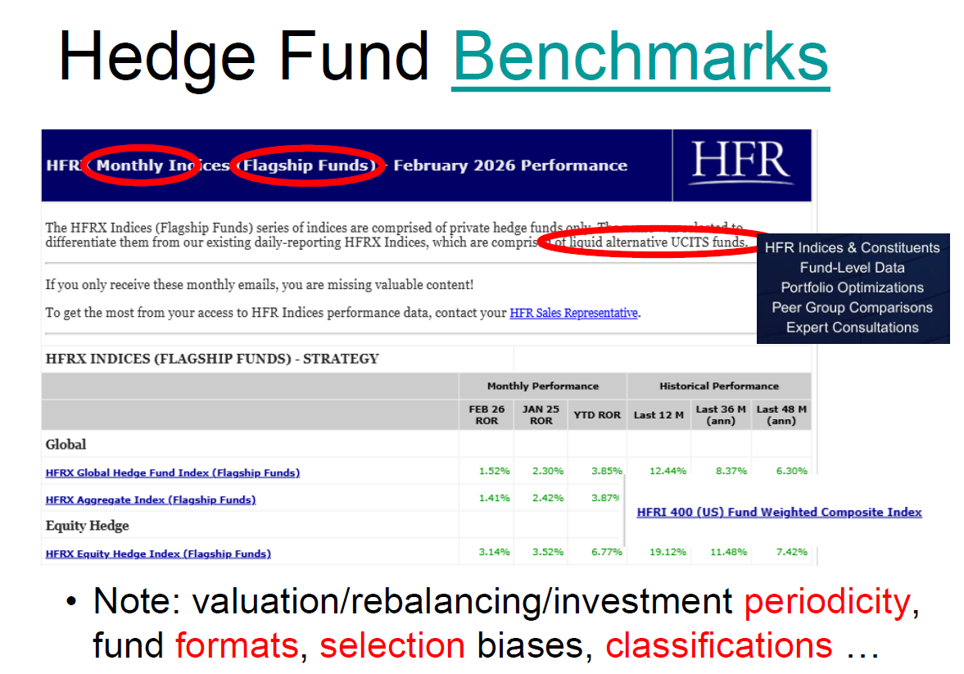
#1 Summary
Slide Summary
The slide is titled "Hedge Fund Benchmarks" and uses an HFR (Hedge Fund Research) data screenshot as its central exhibit. The chart shown is the HFRX Monthly Indices — Flagship Funds report for February 2026, which is an important distinction the professor has circled and highlighted in red.
Two things are circled deliberately in the slide to draw your attention:
- "Monthly Indices (Flagship Funds)" — meaning this index tracks only the largest, most prominent hedge funds, not the entire universe. This is a selection — not a random or comprehensive sample.
- "Liquid alternative UCITS funds" — the existing daily-reporting HFRX indices are comprised of liquid alternative UCITS funds, which are regulated, more liquid vehicles that behave differently from private hedge funds. The Flagship Funds series was created specifically to differentiate from this.
The performance data shown includes:
- HFRX Global Hedge Fund Index (Flagship): +1.52% in Feb 2026, +12.44% over the last 12 months, +8.37% annualized over 36 months
- HFRX Aggregate Index (Flagship): +1.41% in Feb 2026, +3.87% YTD
- HFRX Equity Hedge Index (Flagship): +3.14% in Feb 2026, +19.12% over last 12 months, +11.48% annualized over 36 months
The bullet point at the bottom is the professor's core analytical warning, highlighting four problems in red: periodicity (how often valuations/rebalancing occur), fund formats (UCITS vs. private funds), selection biases (which funds make it into the index), and classifications (how strategies are categorized). These are the lenses through which you should critically evaluate any hedge fund benchmark.
Xxxxxxxxxxxxxxxxxxxxxxxxxxxxxx
The slide presents hedge fund benchmark indices produced by HFR, focusing on the HFRX (Flagship Funds) series and their reported performance across different time horizons, including monthly, year-to-date, and longer-term annualised returns. The indices shown include the HFRX Global Hedge Fund Index, HFRX Aggregate Index, and HFRX Equity Hedge Index, alongside references to broader benchmarks such as the HFRI 400. The data indicates that equity hedge strategies have delivered relatively strong performance, with returns exceeding 3% in the most recent month, while global and aggregate strategies have generated more moderate returns of around 1.4–1.5%. This suggests that hedge fund performance remains closely linked to underlying market conditions, particularly equity markets, rather than being purely driven by alpha. A critical distinction highlighted in the slide is between HFRI indices, which are based on actual hedge funds and include illiquid and less transparent strategies, and HFRX indices, which are constructed from more liquid, UCITS-style funds and therefore exhibit lower returns and greater exposure to systematic factors. The slide also emphasises key issues in benchmark construction, including differences in valuation frequency, rebalancing methodologies, investment periodicity, fund formats, selection biases, and strategy classifications, all of which complicate the interpretation and comparability of hedge fund benchmarks.
- Share Restrictions
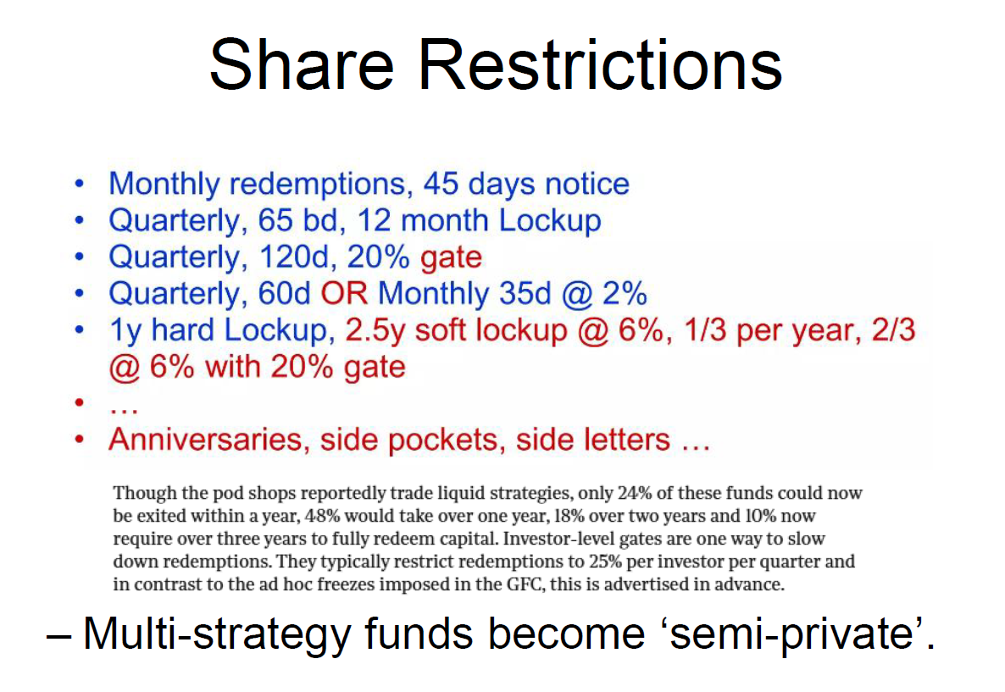
#1 Summary
The slide is titled "Share Restrictions" and covers one of the most practically important — and often underappreciated — features of hedge fund investing: the terms under which investors can get their money back. Unlike mutual funds where you can redeem daily at NAV, hedge funds impose a complex menu of restrictions on withdrawals. The slide lists real-world examples of these structures, progressing from relatively liquid to highly illiquid:
- Monthly redemptions, 45 days notice — the most investor-friendly structure; you can exit monthly but must give 45 days advance warning
- Quarterly, 65 business days notice, 12-month lockup — you can only redeem every quarter, must give ~3 months notice, and can't touch capital at all for the first year
- Quarterly, 120 days notice, 20% gate — even when you can redeem, the fund can limit your exit to 20% of your holding per redemption window
- Quarterly 60 days OR Monthly 35 days @ 2% — a two-tier structure where you pay a 2% fee to exit monthly rather than waiting for the quarterly window
- 1-year hard lockup, 2.5-year soft lockup @ 6%, 1/3 per year, 2/3 @ 6% with 20% gate — the most complex example: capital is completely locked for one year, then partially releasable over 2.5 years but only at a 6% penalty fee, with gate provisions restricting how much can leave at once
The "…" signals these examples are not exhaustive — structures vary enormously. Anniversaries, side pockets, and side letters add further complexity: anniversaries mean you can only redeem on the exact anniversary of your investment; side pockets segregate illiquid assets into a separate account that can't be redeemed at all until the asset is sold; side letters give certain favored investors preferential redemption terms not available to everyone.
The small-print paragraph is striking: even in pod shops (multi-strategy platforms that trade liquid instruments like stocks and futures), only 24% of funds could be fully exited within a year. 48% take over a year, 18% over two years, and 10% require over three years. This is the basis for the slide's punchline: multi-strategy funds are becoming "semi-private" — nominally liquid strategies are in practice behaving like private equity in terms of capital lock-up.
Xxxxxxxxxxxxxxxxxxxxxxxxxxxxxxxxxxxxxxxxxxxxxxxxxxx
The slide outlines the various forms of share restrictions commonly imposed by hedge funds, highlighting the limited liquidity available to investors despite many strategies appearing relatively liquid. It presents a range of redemption structures, including monthly and quarterly redemption frequencies with associated notice periods, as well as more restrictive arrangements such as hard and soft lock-up periods. A hard lock-up prevents investors from redeeming capital for a fixed period, while a soft lock-up allows withdrawal subject to a penalty fee. The slide also emphasises the use of redemption gates, which limit the proportion of capital that can be withdrawn at any given time, and additional mechanisms such as side pockets, which segregate illiquid assets, and side letters, which grant preferential terms to selected investors. Importantly, the data suggests that only a small proportion of funds can be exited within one year, with many requiring multiple years for full redemption, illustrating the significant liquidity constraints in the hedge fund industry. This leads to the key conclusion that multi-strategy hedge funds increasingly resemble “semi-private” vehicles, combining elements of both liquid and illiquid investment structures.

#4 Service Providers, Economics Incentives

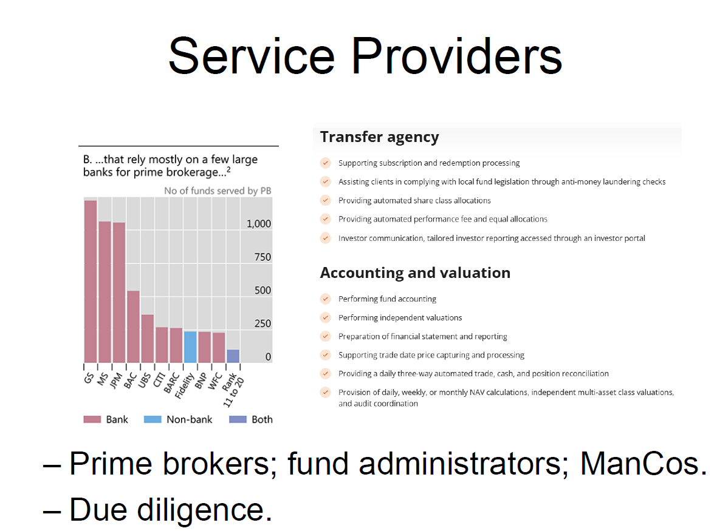
#1 Summary
The slide is titled "Service Providers" and covers the ecosystem of third-party firms that hedge funds rely on to operate. The second image simply shows the title of the next slide — "Economics: Incentives" — which is a separate topic.
The Bar Chart — Prime Brokerage Concentration
The chart is titled "...that rely mostly on a few large banks for prime brokerage" and shows the number of hedge funds served by each prime broker (PB). The key observations are:
Goldman Sachs (GS) and Morgan Stanley (MS) dominate at roughly 1,000+ funds each, followed by JP Morgan (JPM) and Bank of America (BAC) in the 500–600 range, then UBS, Citi, Barclays (BARC) clustered around 250–350. Fidelity and WFC appear as the only significant non-bank prime brokers (shown in blue), serving far fewer funds. The "Rank 11 to 20" bar is tiny, confirming that the industry is extremely concentrated in the top handful of providers.
The critical takeaway from this chart is systemic concentration risk: most of the global hedge fund industry depends on a small number of large bank prime brokers for their most essential operational functions. When Lehman Brothers collapsed in 2008, hedge funds using it as a prime broker had assets frozen overnight — this chart illustrates why that risk hasn't gone away.
The Transfer Agency and Accounting/Valuation Panel
The right side of the slide outlines what fund administrators do — the back-office service providers who handle everything the fund manager doesn't (and shouldn't) do themselves. Transfer agency covers subscription/redemption processing, AML compliance, share class allocations, performance fee calculations, and investor reporting. Accounting and valuation covers fund accounting, independent NAV calculation, financial statement preparation, trade reconciliation, and audit coordination. The emphasis on independence is deliberate — having a third party calculate NAV and perform valuations is a governance safeguard against managers marking their own books.
The bottom bullets summarize the three pillars: prime brokers (financing, securities lending, execution), fund administrators (back-office and NAV), and ManCos (Management Companies — regulated entities that provide a governance and regulatory wrapper, particularly in UCITS/AIFMD structures). Due diligence is flagged as the critical investor responsibility when evaluating all of these.
Xxxxxxxxxxxxxxxxxxxxxxxxxxxxxxxxxxxxxxxxxxxxxxxxxxxxxxxxxxxxxxxxxxxxxxx
🧠 1. Slide Summary — Service Providers
The slide outlines the key service providers in the hedge fund ecosystem and highlights their importance for operational infrastructure, risk management, and investor protection. It focuses on three main categories: prime brokers, fund administrators, and management companies (ManCos), and emphasises the role of due diligence in selecting and monitoring these providers.
The chart on the left shows that hedge funds rely heavily on a small number of large banks for prime brokerage services, with institutions such as Goldman Sachs, Morgan Stanley, and JPMorgan dominating the market. The number of funds served declines significantly beyond these top providers, indicating a high degree of concentration in prime brokerage. This concentration implies both efficiency benefits and systemic risks, as disruptions to a major prime broker could have widespread effects across many hedge funds.
On the right-hand side, the slide details the functions of transfer agents and fund administrators, including processing subscriptions and redemptions, ensuring compliance with regulatory requirements such as anti-money laundering checks, maintaining investor records, calculating performance fees, and providing investor reporting. It also highlights the role of accounting and valuation services, including independent valuation, NAV calculation, reconciliation of trades and cash positions, and preparation of financial statements. These functions are critical for ensuring transparency, accuracy, and operational integrity in hedge fund management.
Overall, the slide emphasises that hedge funds are not standalone entities but depend on a network of specialised service providers, and that the quality and reliability of these providers are central to both fund performance and risk management.

#5 Highwater Mark
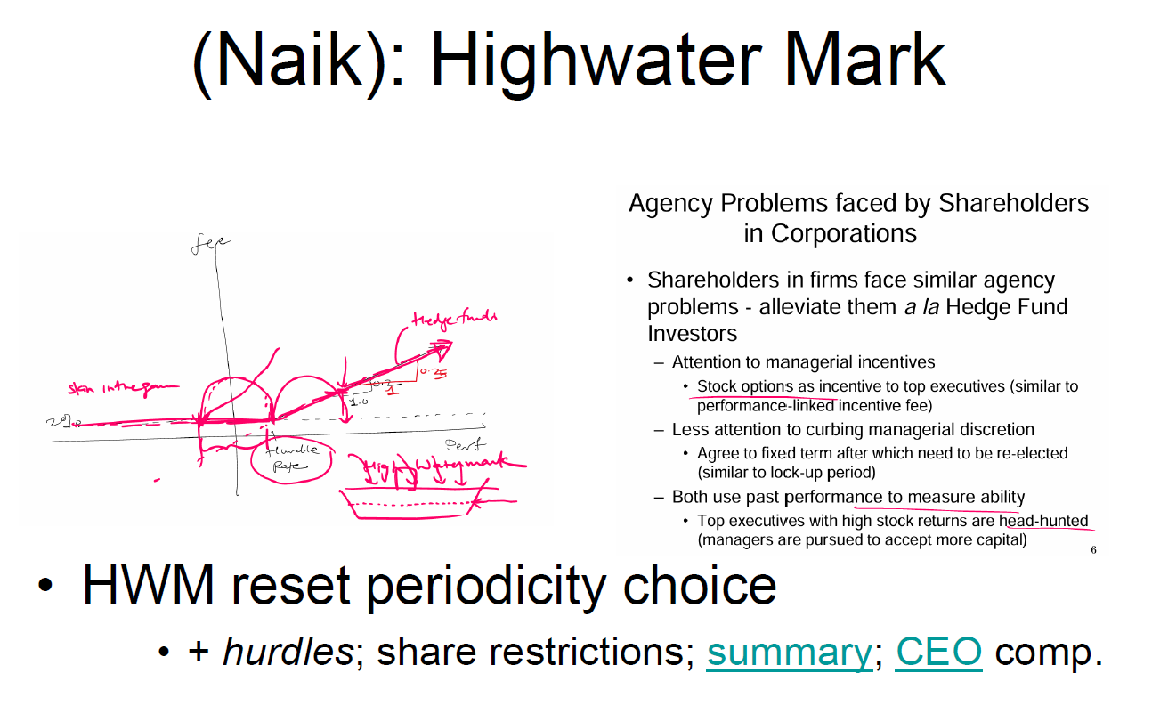
Summary https://thehedgefundjournal.com/role-of-managerial-incentives-flexibility-and-ability/
Role of Managerial Incentives, Flexibility, and Ability
Evidence from performance and money flows in hedge funds
Narayan Naik, Vikas Agarwal and Naveen D. Daniel
The following is a study by Narayan Naik, Director, Centre for Hedge Fund Research and Education, London Business School, together with Vikas Agarwal and Naveen D. Daniel from Georgia State University.
When a principal asks an agent to perform a task (e.g., when an investor asks a fund manager to invest on his or her behalf), invariably agency problems arise. These problems take the form of potential conflict of interests between fund managers and investors and abuse of managerial decision-making freedom.
Interestingly, investors in mutual funds and hedge funds deal with these two problems very differently. To address the problem of conflict of interests, hedge fund investors pay performance-linked incentive fees and require co-investment by the manager, while mutual fund investors typically pay a fixed fee and do not ask managers to invest in their funds.
To mitigate the problem of abuse of managerial latitude, mutual fund investors use regulation, disclosure, and imposition of risk limits. In extreme circumstances, investors even take legal action against their managers as we saw in the case of the Unilever pension fund versus Merrill Lynch Investment Managers.
In contrast, hedge fund investors recognize the beneficial effects of managerial discretion and accept impediments to capital withdrawal to provide the manager with greater investment flexibility. These different approaches have important implications for fund performance and money flows from investors.
There exist interesting similarities in the way shareholders in corporations and investors in hedge funds address these agency problems. For managerial incentives, similar to hedge fund investors paying performance-linked incentive fee to their managers, shareholders in corporate firms award their top executives stock options as part of their compensation. For managerial flexibility, analogous to hedge fund investors locking in their capital during the lockup period after which they are free to divest, shareholders in corporations grant their board of directors a fixed term in office after which they need to be re-elected. These similarities suggest that there may be lessons that shareholders in corporations and investors in hedge funds can learn from each other's experience.
Hurdle rates and high-water marks
Although our delta measure takes into account hurdle rate and high-water mark provisions, the very presence of these provisions may have a direct impact on performance. For example, Lambert and Larcker (2004) show that the optimal contract for managers is frequently one that involves out-of-the-money options.Since hurdle rate and high-water mark provisions effectively make the call option out-of-the-money, arguably such features should motivate the managers to deliver superior performance. Therefore, we also included hurdle rate and high-water mark provisions as our other two proxies for managerial incentives. One expects funds with greater managerial incentives to perform better and to attract greater money flows.
Next, we proxied managerial flexibility by the extent of impediments to capital withdrawals, namely, lockup, notice, and redemption periods, specified in the contract. Arguably, higher impediments to withdrawals provide the manager with greater freedom to follow different investment strategies. Therefore, one expects funds with greater managerial flexibility to display better performance. Although investors prefer better performance, all else equal, in order to meet unanticipated liquidity needs, one expects hedge fund investors to place more money into funds with lower lock-up, notice, and redemption periods.
Finally, we believe that a useful proxy for managerial ability would be the performance record (returns and persistence in returns) of a fund. Due to limited disclosure, hedge fund investors have restricted access to information on portfolio holdings. Furthermore, due to the dynamic nature of hedge fund trading strategies, periodic information on holdings may be of limited use. Therefore, investors may be forced to rely on past performance and persistence in performance to infer managerial ability. In such a case, one would expect funds with better past performance to attract larger money flows.
Using a union of four large hedge fund databases (CISDM, HFR, MSCI, and TASS) we investigated how managerial incentives and flexibility related to the performance of and money flows in the hedge fund industry. We found that hedge funds with greater managerial incentives are associated with better performance (higher returns, more likely to be persistent winners, and less likely to be persistent losers).
Investors seem to recognize the benefits of managerial incentives such as performance-linked incentives fees as these funds are rewarded with higher money inflows.
Funds with greater managerial flexibility also generate higher returns and are more likely to be persistent winners and less likely to be persistent losers. However, investors dislike restrictions such as longer lockup periods since they cannot liquidate their investment as and when they need the money. Accordingly, we found that money flows were lower for funds with greater managerial flexibility. The study also showed that investors directed more money into funds with superior past performance, as this can be seen as a proxy for managerial ability. In such a case, one would expect funds with better past performance to attract larger money flows.
These results are important in shedding light on the efficacy of the contractual arrangements in the hedge fund industry. They also have significant implications for investors and managers – the results can help investors in improving the capital allocation process and fund managers in increasing their enterprise value. Given the recent trend of retail investors investing in hedge funds, we suggest that these results will also be of interest to regulators.
Results analysis
Our investigation has uncovered many results that are new to hedge fund managers. First, it shows that funds with better managerial incentives and greater managerial flexibility are associated with higher returns. Also, such funds are more likely to exhibit persistently good (above-median) returns and are less likely to exhibit persistently poor (below median) returns. It documents that funds with better managerial incentives experience more money flows while funds with higher managerial flexibility (i.e. greater impediments to withdrawals) attract less money flows; funds with better managerial ability will generally attract higher money flows. Overall, these findings have served to significantly improve our understanding of the determinants of performance and money flows in the hedge fund industry.
The findings contribute to several areas of finance: our findings of managerial incentives being positively related to performance has interesting implications for the corporate finance literature. Our proxies for incentives do not suffer from potential endogeneity problems, and thus provide a cleaner test of the relation between managerial incentives and performance.
Second, our findings regarding the effects of incentive-linked compensation have interesting implications for the mutual fund industry. Elton, Gruber and Blake (2003) have already studied the performance of mutual funds charging symmetric fulcrum-type incentive fees. This design of incentive fee contract differs from that in hedgefunds that have an asymmetric call-option-like incentive fee contract. Our findings enable the comparison of the performance implications of offering symmetric versus asymmetric incentive fee contracts.
In addition, the discovery that funds with high-water mark provisions have higher returns has interesting implications for executive compensation literature. Despite Lambert and Larcker's prediction that the optimal contract for corporate managers is frequently one that involves out-of-the-money options, it is difficult to test that prediction in corporations, since most firms (95% according to Murphy, 1999) award at-the-money options to their top executives. Given the imposition of hurdle rate and high-water mark results in grant of out-of-money options to hedge fund managers however, our findings do provide empirical support to Lambert & Larcker's predictions. They also suggest that more research is required concerning performance implications of granting out-of-the-money options to top executives.
Our discovery that higher managerial flexibility is associated with better performance has additional implications for agency theoretic literature. Although agency theory predicts a negative relation between managerial latitude and performance, empirical evidence in the corporate finance literature has been mixed.1 Arguably, self-serving incentives created by managerial latitude would be restrained in hedge funds, since managers are co-investors and face strong financial incentives. Thus, our finding suggests that it may be possible to counter negative effects of managerial latitude through appropriate financial contractual arrangements.
Finally, given the similarities between hedge fund managers' contracts and those of the top executives of corporations, the findings also have wider implications in the field of executive compensation.
A full copy of this report is available from the London Business School (+44 207 262 5050) www.london.edu
Agrawal A. and C.R. Knoeber, 1996, "Firm performance and mechanisms to control agency problems between management and shareholders," Journal of Financial and Quantitative Analysis, 31, 377-397 Berger, P.G., O. Eli, and L.Y. David, 1997,
"Managerial enrichment and capital structure decisions," Journal of Finance, 52, 1411-1438 Denis, D.J., D.K. Denis, and A. Sarin, 1997,
"Agency problems, equity ownership and corporate diversification," Journal of Finance, 52, 135-160. Donaldson, L., and J.H. Davis, 1991, "Stewardship theory or agency theory: CEO governance and shareholder returns," Australian Journal of Management, 16, 49-64.
Elton, Edwin J., Martin J. Gruber, and Christopher R. Blake, 2003, "Incentive Fees and Mutual Funds," Journal of Finance, 58(2), 779-804.
Kesner, I.F., 1987, "Directors' stock ownership and organizational performance: An investigation of Fortune 500 companies," Journal of Management, 13, 499-508.
Lambert and Larcker, Richard A., and David F. Larcker, 2004, "Stock Options, Restricted Stock, and Incentives," Working Paper, University of Pennsylvania
1 Several studies have examined the relation between managerial discretion and performance. Berger at al (1997) and Denis et al (1997) find a negative relation, Demsetz and Lehn (1985) and Agrawal and Knoeber (1996) find no relation, while Kesner (1987) and Donaldson and Davis (1991) find a positive relation between managerial discretion and performance.

CEO Podcast https://podcasts.apple.com/us/podcast/are-ceos-paid-just-for-luck/id1741997589?i=1000698060236

1.1 Summary
The slide is titled (Naik): Highwater Mark and brings together two interconnected ideas: the mechanics and incentive effects of high-water mark provisions in hedge funds, and a parallel drawn to agency problems in corporate governance.
The Hand-Drawn Diagram
The sketch on the left is a professor's diagram of how hedge fund performance fees work as a function of returns. The axes are Fee (vertical) and Performance (horizontal). The key features drawn are:
- A hurdle rate on the horizontal axis — the manager earns zero performance fee until returns exceed this threshold
- A high-water mark (HWM) level — the manager cannot collect performance fees again after a drawdown until the previous peak NAV is recovered
- The fee line is flat (zero) until the hurdle rate is crossed, then slopes upward at the agreed carry rate (e.g., 20%)
- The annotation "0.25" and "1.0" likely refer to the delta of the option — at-the-money the option delta is around 0.5, but with HWM and hurdle provisions the effective delta starts lower
- The label "hedge funds" with an arrow pointing to the steeper slope region, and "skin in the game" labelled on the left, referencing manager co-investment
The diagram is essentially showing that the performance fee structure is a call option on fund returns: the manager receives a percentage of profits above the HWM/hurdle, just like the holder of a call option profits above the strike price. The HWM reset periodicity bullet at the bottom is the key refinement — how often the HWM resets (annually, at redemption, etc.) materially changes the value of this option and the incentives it creates.
The Corporate Governance Parallel
The right panel draws a direct analogy between hedge fund investor-manager relationships and shareholder-CEO relationships in corporations:
- Stock options ≈ performance-linked incentive fees: both align the agent's compensation with the principal's returns
- Fixed board terms ≈ lockup periods: both give the agent stability and discretion for a defined period before accountability kicks in
- Past performance used to measure ability in both contexts: top executives with high stock returns get headhunted; successful hedge fund managers attract more capital
The bottom bullet — HWM reset periodicity choice + hurdles; share restrictions; summary; CEO comp — signals that these topics are linked across slides and should be understood as a unified framework of incentive design.
Xxxxxxxxxxxxxxxxxxxxxxxxxxxxxxxxxxxxxxxxxxxxxxxxxxxxxxxxxxxxxxxxxxxxxxxxxxx
The slide explains how high-water mark (HWM) contracts shape hedge fund manager incentives, linking them to broader agency problems similar to those found in corporate governance.
The diagram on the left illustrates the option-like payoff structure of hedge fund fees. The horizontal axis represents fund performance, while the vertical axis represents fees earned by the manager. The manager earns performance fees only when returns exceed a threshold, defined by the high-water mark and hurdle rate. After a loss, the manager must recover previous losses before earning fees again, making the incentive contract resemble an out-of-the-money call option. This creates convex payoffs, where managers benefit disproportionately from upside performance while not being penalised symmetrically for losses. The slide also highlights that the reset periodicity of the high-water mark is an important contractual choice, as frequent resets may weaken incentives, while infrequent resets strengthen them.
On the right-hand side, the slide draws a parallel between hedge fund managers and corporate executives, emphasising that both face similar agency problems. Hedge fund managers are incentivised through performance fees, while corporate executives are compensated through stock options, both of which link pay to performance. Additionally, both systems rely on past performance as a proxy for ability and provide managers with a degree of discretion, such as through lock-ups in hedge funds or fixed terms for corporate boards.
The underlying research by Narayan Naik and co-authors shows that stronger managerial incentives (e.g. high-water marks and hurdle rates) are associated with better performance, and that greater managerial flexibility (e.g. longer lock-ups) also improves performance, although investors tend to dislike such restrictions. The slide therefore highlights a key trade-off between incentives, flexibility, and investor preferences, with implications for performance and capital flows.

#2 Link Reference - Role of Managerial Incentives, Flexibility, and Ability
Summary (Exam-ready paragraph)
The study by Narayan Naik, Vikas Agarwal, and Naveen Daniel examines how hedge fund contractual structures address agency problems and how these structures affect performance and capital flows. The authors highlight that agency problems arise from conflicts of interest and managerial discretion, and that hedge funds address these issues differently from mutual funds. While mutual funds rely on regulation, disclosure, and constraints on manager behaviour, hedge funds use performance-based incentives (such as incentive fees, high-water marks, and hurdle rates) and manager co-investment to align interests, while simultaneously granting managers greater flexibility through lock-ups and redemption restrictions.
The study shows that these contractual features have important performance implications. High-water marks and hurdle rates make compensation resemble out-of-the-money call options, strengthening incentives and encouraging superior performance. Empirically, funds with stronger managerial incentives are associated with higher returns, greater persistence in performance, and increased capital inflows. Similarly, greater managerial flexibility, achieved through restrictions on capital withdrawal, allows managers to implement more effective strategies and is also associated with better performance. However, investors dislike reduced liquidity, and therefore funds with greater restrictions tend to attract lower capital inflows.
The study also finds that, due to limited transparency and the dynamic nature of hedge fund strategies, investors rely heavily on past performance as a proxy for managerial ability, leading to capital flows being directed toward funds with strong historical returns. Finally, the paper draws parallels between hedge fund contracts and corporate governance, noting that hedge fund incentive fees resemble executive stock options, and lock-up provisions resemble fixed-term contracts for corporate managers. Overall, the study demonstrates that well-designed incentive and flexibility mechanisms can mitigate agency problems and improve performance, but they also create trade-offs in terms of investor preferences and capital allocation.
Key Takeaways (EXAM GOLD)
🔑 1. Two agency problems
- Conflict of interest
- Managerial discretion
👉 Hedge funds solve BOTH differently from mutual funds

🔑 2. Incentives = performance ↑
- Performance fees
- High-water marks
- Hurdle rates
👉 Stronger incentives → better returns + more inflows

🔑 3. Flexibility = performance ↑ BUT flows ↓
- Lockups / redemption restrictions
👉 Allow better investing
BUT
👉 Investors dislike illiquidity

🔑 4. Investors are imperfect
- Cannot observe strategy
- Rely on past performance
👉 Leads to:
- Performance chasing
- Misallocation of capital

🔑 5. Hedge funds ≈ Corporations
- Incentive fees ≈ stock options
- Lockups ≈ CEO contract terms
👉 Same agency solution framework
6. Big trade-off (VERY IMPORTANT)
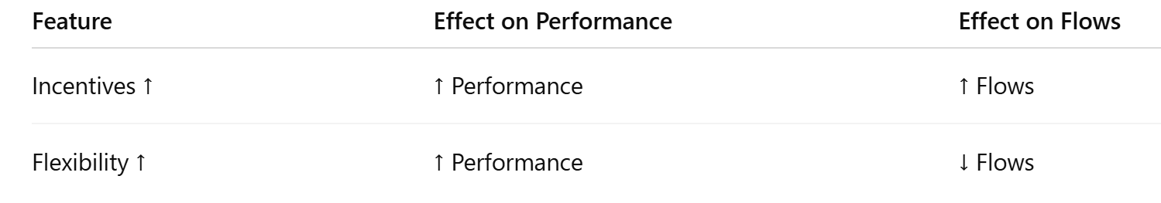
This table = exam gold

Killer Insight
“Hedge fund contracts are designed to solve agency problems through a combination of strong incentives and managerial flexibility, which improves performance but creates a fundamental trade-off with investor liquidity preferences.”

You should ALWAYS mention:
- Incentives (HWM, hurdle)
- Flexibility (lockups)
- Performance vs flows trade-off
- Corporate analogy
That’s how you get 18–20 marks
{ FINAL MEMORY FRAME (CRITICAL)
High-Water Mark =
- No fee until past losses recovered
- Like call option payoff
Key ideas:
- Incentives ↑ → performance ↑
- Flexibility ↑ → performance ↑
- BUT investors dislike lockups
Agency solution =
- Hedge funds → incentives + flexibility
- Corporations → stock options + governance}

#6 Performance Fees

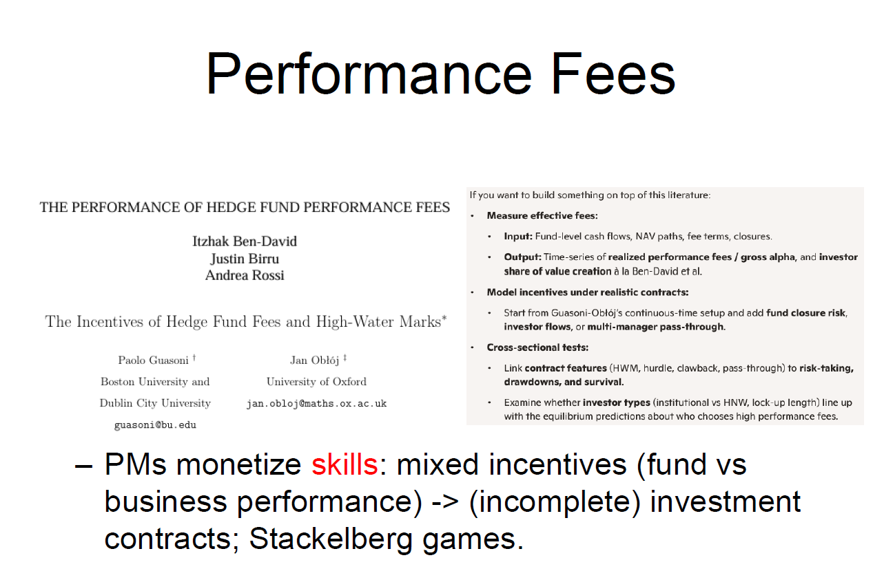
6.1 Summary
The slide is titled "Performance Fees" and synthesizes two major academic papers on hedge fund fee structures, then frames the broader research agenda around how portfolio managers monetize skill through imperfect contracts.
The Two Papers Referenced
The first is Ben-David, Birru and Rossi — "The Performance of Hedge Fund Performance Fees." This paper takes an empirical approach, measuring what investors actually paid in performance fees versus what value was actually created. The key output is a time-series of realized performance fees relative to gross alpha — essentially asking: over the life of a fund, what fraction of value created was captured by the manager versus retained by investors? This is the "investor share of value creation" framing. The finding is striking and damaging to the industry's reputation: because performance fees are asymmetric (managers collect on upside but don't refund fees when losses occur), managers can extract substantial fees over a fund's life even when net long-run alpha for investors is modest or zero. The HWM provision helps but does not fully solve this problem, especially when funds close after drawdowns and reopen fresh.
The second is Guasoni and Oblój — "The Incentives of Hedge Fund Fees and High-Water Marks." This is a theoretical continuous-time model that analyzes the incentive properties of the HWM contract. Rather than asking what fees were actually paid, it asks what behavior the fee structure rationally induces in a forward-looking manager. It models the manager's optimal strategy given the option-like nature of performance fees and derives predictions about risk-taking relative to the HWM position.
The Research Agenda Box
The right panel outlines how a researcher would build on this literature, which also serves as a map of the unresolved questions your professor considers important:
- Measuring effective fees: using actual fund-level cash flows, NAV paths, and closure events to compute realized fees vs. gross alpha
- Modeling incentives under realistic contracts: extending Guasoni-Oblój with fund closure risk, investor flows, and multi-manager pass-through structures (relevant for pod shops)
- Cross-sectional tests: linking contract features (HWM, hurdle, clawback, pass-through) to actual outcomes — risk-taking, drawdowns, survival — and examining whether institutional vs. high-net-worth investors select into different fee structures in line with theory
The Bottom-Line Framing
The professor's key synthesis is: "PMs monetize skills: mixed incentives (fund vs business performance) → incomplete investment contracts; Stackelberg games." This is the most conceptually rich part of the slide and deserves careful unpacking. Portfolio managers are simultaneously running an investment strategy and running a business. These two objectives create mixed incentives — what is optimal for maximizing the fund's investment performance is not always what maximizes the manager's business value (AUM growth, fee income, franchise survival). Because contracts cannot perfectly specify every contingency, they are incomplete — leaving room for managers to exploit gaps. The Stackelberg game framing captures the strategic dynamic: the manager (as first mover/leader) sets the contract terms, and investors (as followers) decide whether to accept. This is not a symmetric negotiation — it is a game where the informed party designs the rules.
Xxxxxxxxxxxxxxxxxxxxxxxxxxxxxxxxxxxxxxxxxxxxxxxxxx
The slide focuses on the economics and incentives of hedge fund performance fees, drawing on key academic work such as The Performance of Hedge Fund Performance Fees by Itzhak Ben-David, Justin Birru, and Andrea Rossi, as well as research by Paolo Guasoni and Jan Obłój on high-water marks and incentive contracts. It highlights that hedge fund performance fees are not simply a fixed “20% of profits” structure, but instead create complex, option-like incentives that affect both manager behaviour and investor outcomes.
The slide emphasises that performance fees should be analysed in terms of effective fees, which depend on fund-level cash flows, NAV paths, fee structures, and closures. Rather than focusing on stated fees, researchers examine realised performance fees relative to gross alpha and the share of value captured by investors versus managers. It also highlights that incentive structures operate within incomplete contracts, meaning that not all contingencies can be specified in advance, leading to strategic interactions between managers and investors. This is reflected in the reference to Stackelberg games, where managers and investors act strategically in response to each other.
A key insight is that portfolio managers (PMs) monetise their skills through performance fees, but face mixed incentives between maximising fund performance and maximising business outcomes, such as asset growth and fee generation. The slide also suggests that empirical research links contract features—such as high-water marks, hurdle rates, and clawbacks—to outcomes like risk-taking, drawdowns, and fund survival. Overall, the slide highlights that hedge fund fees are central to incentive alignment, but also introduce distortions and strategic behaviour that must be carefully analysed.

{Memory}
Performance fees =
- Call option payoff
- Incentives ↑ performance
- BUT risk-taking ↑
Key ideas:
- Effective fees ≠ stated fees
- Contracts = incomplete
- Managers = strategic
#7
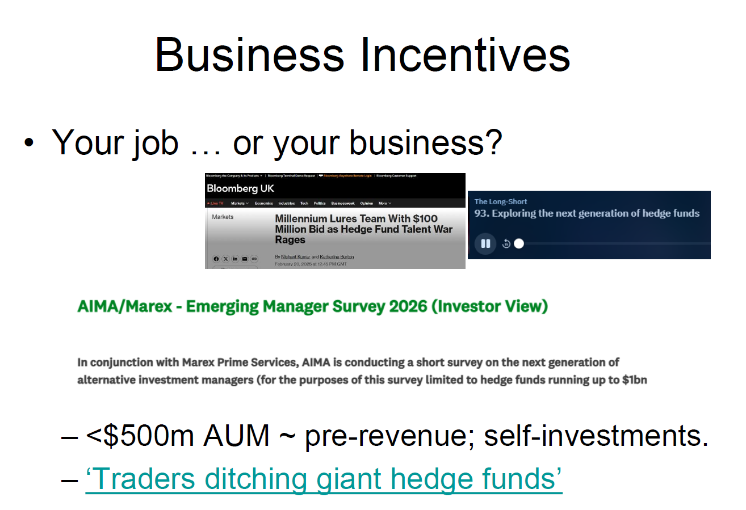
- Bloomberg Link https://www.bloomberg.com/news/articles/2025-02-20/millennium-lures-team-with-100-million-bid-as-talent-war-rages
Millennium Lures Team With $100 Million Bid as Hedge Fund Talent War Rages
As the war to poach portfolio manager Chris Procaccini, 48, erupted among hedge fund giants, industry legend Izzy Englander intervened to secure a victory.
Englander’s offer: $100 million in potential payouts to Procaccini and his team. That deal got the health care-focused portfolio manager to reject at least one rival bid to shut his $2.5 billion fund at Magnetar Capital and join Englander, 76, at his $75.8 billion hedge fund, Millennium Management.
The big payout depends on Procaccini and his team performing over several years. In addition to cash bonuses, they’ll get a higher initial percentage cut from the profits generated, as long as they hit certain goals. Once that period ends, their take settles at 25% of their gains, higher than the average profit split at Millennium, people with knowledge of the matter said.
Millennium and Procaccini declined to comment.
The billionaire hedge fund founder’s last-minute interception underscores just how fierce and expensive the talent battle has become between multistrategy giants, even several years after an explosion of assets began adding pressure to hire more and more people.
Because investors at the biggest multistrategy funds pay all expenses, including compensation, these firms can offer ever-bigger sums of money and perks to poach the most talented traders with the expectation that they’ll more than pay for themselves in higher returns.
Read More: ‘No Limit’ Hedge Fund Fees Are Eating Up Their Clients’ Gains
While such charges exceed the traditional “two and 20” fee most hedge funds still levy, the relatively high net gains and steady performance at the biggest multistrategy firms still attract investors — creating ever-higher demand for traders.
Procaccini previously traded at Hutchin Hill Capital, Highbridge Capital Management and Steve Cohen’s SAC Capital, now Point72 Asset Management.

- Shows Acast.com (https://shows.acast.com/636b781f4a382300110bb134/episodes/6718c66a30187dfb6cb29308? ) 93. Exploring the next generation of hedge funds
The Long-Short (93. Exploring the next generation of hedge funds)
In this episode of The Long-Short, we dive into the often-overlooked world of smaller and emerging hedge funds. While 75% of global hedge funds manage less than $500m in assets, these entrepreneurial managers are rarely highlighted in mainstream media, which tends to focus on multi-billion-dollar firms.

3. AIMA Next Generation Manager Forum 2026
https://www.aima.org/events/aima-next-generation-manager-forum-2026.html
AIMA’s flagship Next Generation Manager Forum, taking place on Tuesday 19 May, 2026, brings together the next wave of leaders from hedge funds and private markets firms managing up to US$1 billion in assets. Designed for senior emerging talent, the Forum offers sponsors and participants an opportunity to engage directly with the future CIOs, portfolio managers, and founders who will shape the industry in the years ahead.
As alternative investment management continues to evolve amid shifting market dynamics, regulatory change, and technological innovation, the Forum provides a focused, half-day platform for timely insight and meaningful exchange. Through candid discussion, expert-led sessions, and high-quality peer networking, attendees will explore the perspectives, skills, and strategies defining the next generation of investment leadership.

#1 Summary
The slide is titled "Business Incentives" and centers on a deceptively simple but profound question: "Your job… or your business?" This frames the core tension for any talented hedge fund portfolio manager — do you work for someone else's platform (a "job") or do you build your own fund (a "business")? The slide uses three real-world sources to illuminate this tension from different angles.
Source 1 — Bloomberg: Millennium's $100 Million Talent War
The headline story is about Millennium Management's Izzy Englander offering a $100 million payout package to lure portfolio manager Chris Procaccini and his team away from Magnetar Capital. Procaccini ran a $2.5 billion healthcare-focused pod at Magnetar. The deal includes cash bonuses, an elevated profit split during an initial performance period, settling at 25% of gains — above Millennium's average. The story illustrates the mechanics of the multi-strategy pod shop model: because investors in these platforms pay all expenses including compensation, the fund can offer enormous sums to top traders with the expectation they'll generate returns that more than cover the cost. This creates a feedback loop — strong performance attracts capital, capital enables bigger hiring bids, bigger hires attract more talent, perpetuating dominance.
Source 2 — The Long-Short Podcast: Emerging Managers
This episode highlights the other side of the same coin: 75% of global hedge funds manage less than $500 million in AUM, yet these smaller, entrepreneurial managers are almost invisible in mainstream financial media. The podcast explores the next generation of hedge fund founders — people who chose "your business" over "your job."
Source 3 — AIMA Next Generation Manager Forum 2026
AIMA's flagship forum for managers running up to $1 billion in AUM, focusing on emerging talent who will become the next CIOs and fund founders. It contextualizes the industry's generational transition and the structural challenges facing new entrants.
The Two Bottom Bullets
These are the professor's analytical punchlines. First: "<$500m AUM ~ pre-revenue; self-investments" — a fund under $500 million in AUM, charging 2% management fee, generates less than $10 million in annual management fee revenue. After paying rent, technology, compliance, prime brokerage, and salaries, the founder is often running at a loss or breakeven — surviving on personal capital invested in the fund. The management fee covers operations only at scale. Second: "Traders ditching giant hedge funds" — a reference to the countervailing trend of talented PMs leaving large platforms to launch their own funds, accepting lower near-term income in exchange for ownership, autonomy, and the long-term upside of building equity in their own business.
Xxxxxxxxxxxxxxxxxxxxxxxxxxxxxxxxxxxxxxxxxxxxxxxxxxxxxxxxxxxx
The slide highlights the fundamental tension in hedge fund management between treating portfolio management as a job versus as a business. It shows that incentives in the hedge fund industry are increasingly shaped not only by investment performance but also by business considerations such as compensation structures, asset growth, and career dynamics.
The Bloomberg example illustrates the intense competition for talent, where large multi-strategy funds such as Millennium Management offer extremely high compensation packages (e.g. $100 million potential payouts) to attract top portfolio managers. These compensation structures often include profit-sharing arrangements (e.g. 25% of profits), aligning incentives but also increasing costs borne by investors.
The slide also highlights the importance of emerging managers, with most hedge funds managing less than $500 million in assets and often operating as entrepreneurial, pre-revenue businesses with significant manager co-investment. This reflects a different incentive structure compared to large funds, where managers may prioritise building a business (raising AUM) versus generating pure investment returns.
The AIMA/Marex survey and related materials emphasise that the next generation of hedge fund managers operates in a rapidly evolving environment characterised by competition for capital, talent, and differentiation. The key takeaway is that hedge fund managers face mixed incentives: they must balance maximising fund performance (to earn performance fees) with growing their business (to increase management fees and enterprise value), leading to strategic behaviour and potential conflicts with investors.

Summary of Source Links
🔹 Bloomberg (Talent War) https://www.bloomberg.com/news/features/2026-03-17/traders-are-ditching-giant-hedge-funds-to-set-their-own-terms

- Massive competition for PM talent
- Multi-strategy funds:
  - Offer huge payouts (e.g. $100m packages)
  - Profit-sharing (e.g. 25%)
- Investors effectively pay for talent
- → Costs passed to investors via fee structure
👉 Insight:
Hedge funds = talent-driven industry

Podcast (Next Generation Funds)
- ~75% of hedge funds < $500m AUM
- Emerging managers:
  - Underrepresented
  - Entrepreneurial
- Industry not just mega-funds
👉 Insight:
Most hedge funds are small businesses, not giants

AIMA Forum
- Focus on next-generation managers (<$1bn AUM)
- Industry evolving:
  - Regulation
  - Technology
  - competition
> Insight:
Future industry = more competitive, more fragmented
{Memory}
>Hedge funds = NOT just investing → also a BUSINESS
> Key tension:
- Fund performance (alpha)
- vs
- Business performance (AUM, fees)
> Industry reality:
- Talent war
- Small funds dominate
- Incentives drive behaviour

Conclusion
Hedge funds operate at the intersection of investment performance and business incentives, where the pursuit of alpha must be balanced against the economic realities of asset gathering, compensation, and competition for talent.

#7 Investor Incentives

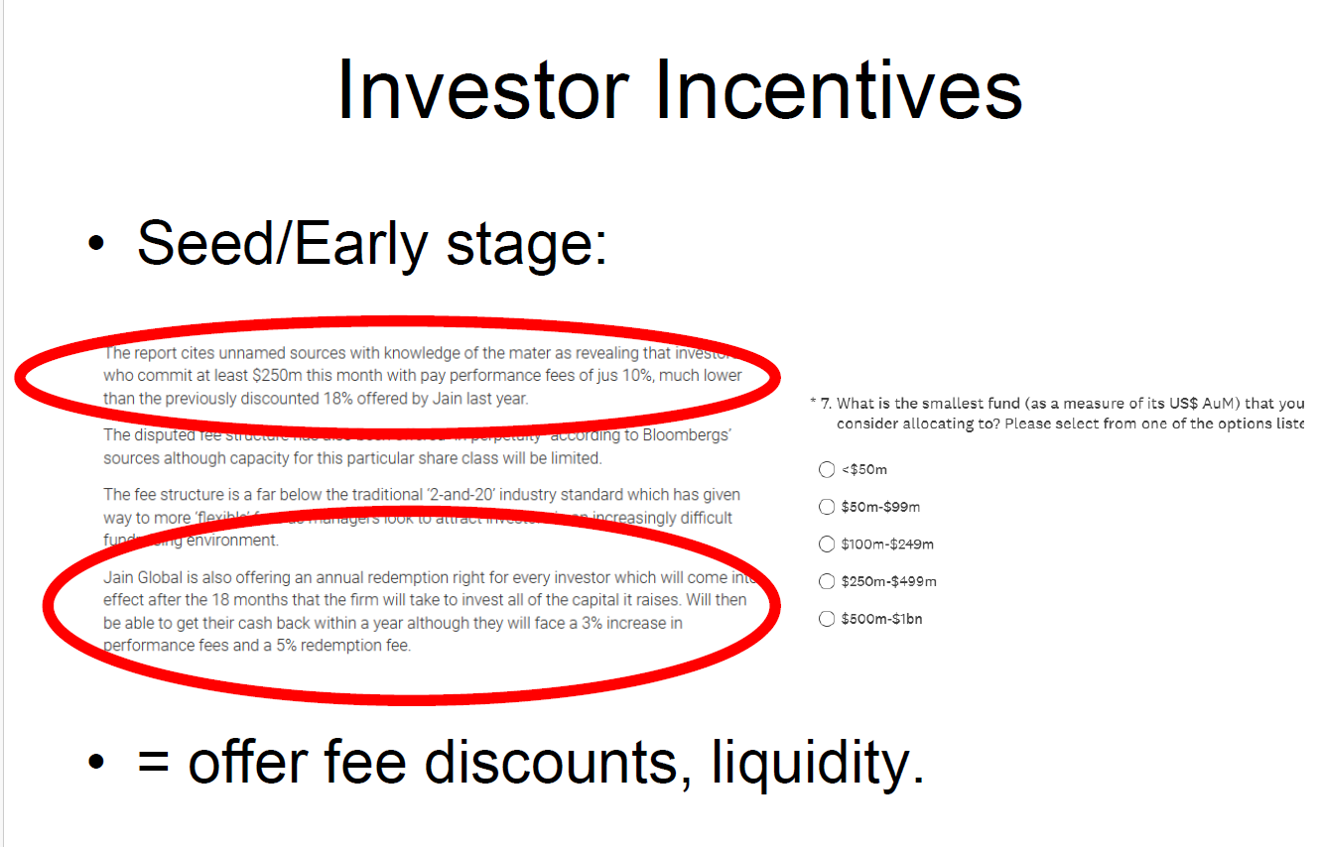

#7.1 Summary
The slide is titled "Investor Incentives" and focuses on the seed and early-stage phase of a hedge fund's life — specifically, what incentives emerging managers must offer investors to attract capital when they have no established track record and are competing against larger, more credible funds.
The Two Circled Passages — The Jain Global Example
The professor has circled two key excerpts from what appears to be a news article about Jain Global, an emerging fund launch. These are the concrete real-world examples anchoring the slide's argument:
The first circled passage reveals that early investors committing at least $250 million would pay performance fees of just 10% — dramatically below the standard 20%, and even below the previously discounted 18% Jain had offered earlier. The fee structure is described as well below the traditional 2-and-20 standard, reflecting a more flexible approach as managers compete harder to attract capital in a difficult fundraising environment. The fee discount is offered in perpetuity for this share class, though capacity is limited.
The second circled passage describes the liquidity terms: Jain Global offers an annual redemption right that kicks in after an 18-month deployment period. However, investors who want to exit early (within a year after the lockup) face a 3% increase in performance fees plus a 5% redemption fee — a classic soft lockup structure that offers liquidity but prices it to discourage short-term exits.
The AIMA Survey on the Right
The right side shows a survey question asking institutional investors: "What is the smallest fund (by AUM) you would consider allocating to?" with options ranging from under $50 million to $500 million–$1 billion. This is directly relevant to the slide's theme — it quantifies the institutional investor's minimum size threshold, which defines the fundraising challenge emerging managers face. Most institutional allocators have a floor well above where most emerging funds operate.
The Bottom-Line Bullet
The professor's synthesis: "= offer fee discounts, liquidity." This is the entire strategic toolkit for attracting seed and early-stage capital compressed into four words. To compensate for the absence of a long track record, emerging managers must offer investors something in exchange — either cheaper access (lower fees) or better terms (more liquidity), or both simultaneously as Jain Global did.
Xxxxxxxxxxxxxxxxxxxxxxxxxxxxxxxxxxxxxxxxxxxxxxxxxxxxxxxxxxxx
The slide explains how investor incentives shape hedge fund fee structures and liquidity terms, particularly in the seed and early-stage phase of a hedge fund’s lifecycle. It highlights that large early investors, especially those committing significant capital (e.g. $250 million or more), have substantial bargaining power and are often able to negotiate discounted performance fees, sometimes as low as 10%, compared to the traditional 20% benchmark. In addition to fee discounts, these investors may also receive enhanced liquidity terms, such as earlier redemption rights, reduced lock-up periods, or preferential withdrawal options.
The example shown illustrates that investors in certain funds (e.g. Jain Global) are offered the ability to redeem capital after a defined investment period (e.g. 18 months), albeit with conditions such as slightly higher performance fees or redemption fees. This demonstrates that hedge fund contracts are highly flexible and tailored, with terms negotiated between managers and investors rather than standardised. The slide also implicitly reflects how investor preferences—particularly for lower fees and greater liquidity—interact with managers’ need to secure stable capital and fund growth. Overall, the key takeaway is that investors, especially early and large investors, can influence contract terms significantly, leading to fee dispersion and heterogeneity in liquidity provisions across hedge funds.
{Memory}
> Early investors = powerful
- Fee discounts
- Better liquidity
- Core trade-off:
- Lower fees ↔ less liquidity
- More liquidity ↔ higher fees
> Industry reality:
- “2 and 20” is NOT standard anymore

Conclusion
Hedge fund contracts are highly negotiated, with large early-stage investors leveraging their bargaining power to secure fee discounts and improved liquidity, resulting in significant heterogeneity in fee structures across the industry.

#8 Alpha Statistics
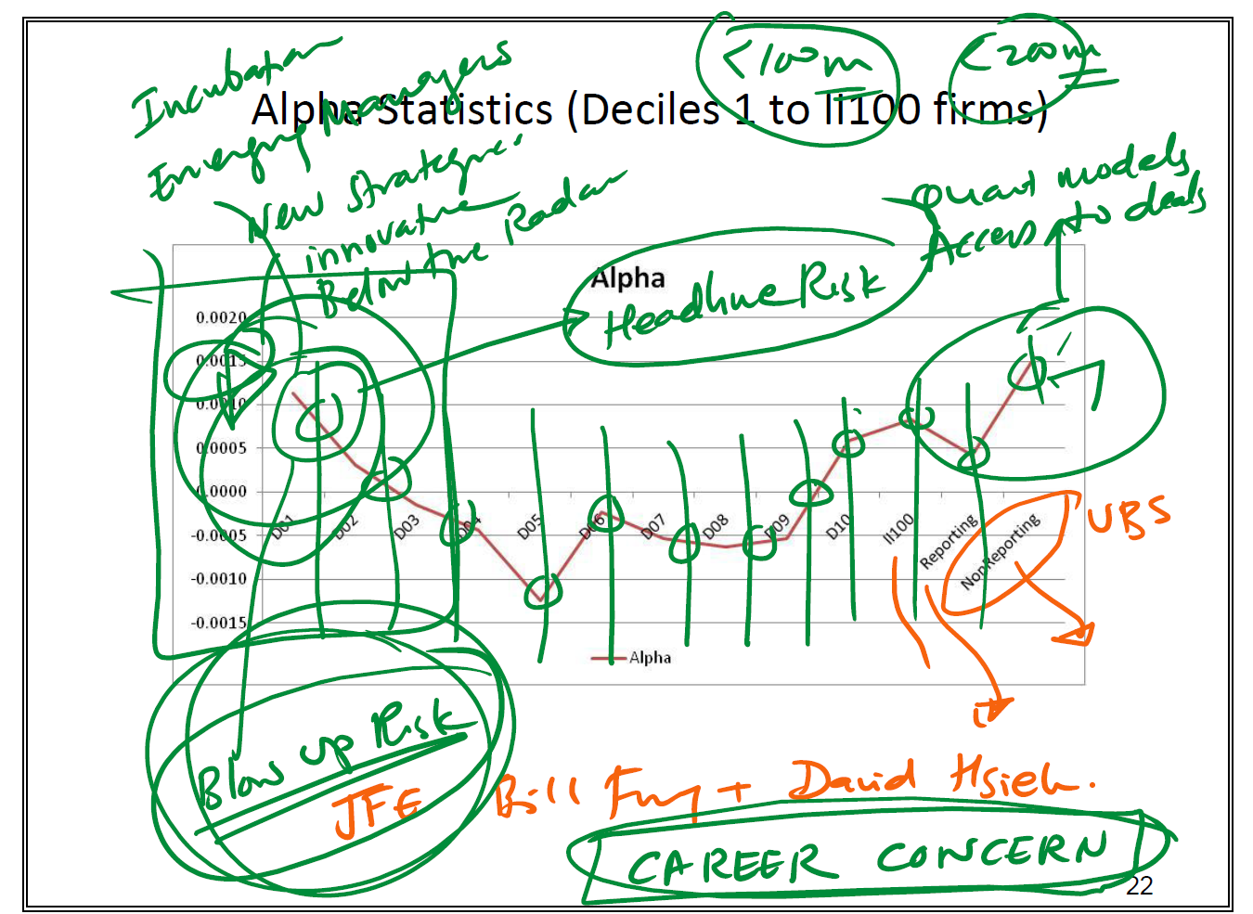
#8.1 This is a heavily annotated professor's slide showing a chart titled "Alpha Statistics (Deciles 1 to II100 firms)" — likely drawn from a Fung and Hsieh / UBS research paper published in the Journal of Financial Economics (JFE). The professor has annotated the chart extensively in green and orange to highlight the key interpretive points. Let me decode everything systematically.
The Underlying Chart
The horizontal axis shows fund groupings: D01 through D10 (deciles 1–10 of the fund universe ranked by some characteristic, likely AUM or performance) plus II100 (the top 100 institutional-quality funds), and then two final bars for Reporting vs Non-reporting funds. The vertical axis shows alpha — daily or monthly abnormal return above a factor model benchmark. The pink/red line traces alpha across these groups, forming a distinctive pattern: highest alpha at D01 (the smallest/earliest decile), declining and turning negative in the middle deciles (bottoming around D05–D06 at approximately -0.0013), then recovering and rising toward positive territory for the II100 and larger funds.
The Professor's Green Annotations — Left Side
Around D01 (top left), the professor has written: "Incubation," "Emerging managers," "New strategies," "Innovative," "Below the radar" — and circled the high-alpha region. The labels "<100m" and "<200m" (circled at the top) indicate these are very small funds. This cluster represents the sweet spot of genuine alpha generation: tiny, innovative, incubating funds flying below the radar of institutional capital, deploying new strategies before they become crowded. The annotation "Blow up risk" is circled at the bottom left — the caveat. These small funds generate the highest measured alpha but also carry the highest risk of catastrophic failure.
The Professor's Green Annotations — Right Side
On the right side around II100 and the Reporting group, the annotations read: "Quant models," "Access to deals" — indicating that the large institutional funds (II100) recover positive alpha through two sources: systematic quantitative edge and privileged deal access (think large funds getting into IPOs, private placements, or over-the-counter transactions unavailable to smaller players). The orange annotation distinguishes "Reporting" (positive alpha) vs "Non-reporting" funds (negative alpha, circled), with an arrow pointing to "UBS" — attributing this data to UBS research.
The Bottom Annotations
In orange: "Bill Fung + David Hsieh" — confirming the academic source. In green: "CAREER CONCERN" circled prominently at the bottom. This is the professor's most important editorial comment — career concern is the behavioral explanation for why middle-decile funds show negative alpha. Managers running mid-sized funds are not optimizing purely for returns; they are managing career risk, making conservative decisions to avoid blowups that would end their employment, even at the cost of performance.
---------------------------------------------------------------------
What the Whole Slide Is Saying — The Big Picture
This slide is making one of the most important and counterintuitive arguments in the entire hedge fund course: the relationship between fund size/maturity and alpha generation is not linear — it is U-shaped — and the reasons why tell you almost everything about how the hedge fund industry actually works.
Let me walk through the complete narrative the professor is building.
The Central ArgumentThe slide is showing empirically, using Fung & Hsieh's JFE research backed by UBS data, that alpha is not evenly distributed across the hedge fund universe. Where you find alpha — and where you don't — reveals the true drivers of outperformance, the behavioral distortions created by career incentives, and the structural advantages of operating at the extremes of the size spectrum.
What the Whole Slide Is Saying — The Big Picture
This slide is making one of the most important and counterintuitive arguments in the entire hedge fund course: the relationship between fund size/maturity and alpha generation is not linear — it is U-shaped — and the reasons why tell you almost everything about how the hedge fund industry actually works.
Let me walk through the complete narrative the professor is building.

The Central Argument
The slide is showing empirically, using Fung & Hsieh's JFE research backed by UBS data, that alpha is not evenly distributed across the hedge fund universe. Where you find alpha — and where you don't — reveals the true drivers of outperformance, the behavioral distortions created by career incentives, and the structural advantages of operating at the extremes of the size spectrum.

Part 1: The Small Fund Alpha (Left Side — D01, D02)
The highest alpha in the entire dataset sits with the tiniest funds — below $100–200 million AUM. The professor labels these: incubation funds, emerging managers, new strategies, innovative, below the radar.
Why do tiny funds generate the most alpha?
Three reinforcing reasons:
Capacity constraints work in their favor. A $50 million fund can invest in a small-cap stock, an obscure convertible bond, or an illiquid credit instrument and generate meaningful returns. A $5 billion fund cannot touch the same trade — it would move the market against itself just by entering the position. Small funds have access to a much larger universe of exploitable mispricings simply because they need less size to make those trades matter.
They are genuinely innovative. The very act of launching a new fund usually means implementing a strategy that isn't yet crowded. Alpha is highest at the moment before a strategy becomes widely known and replicated. These managers are doing something others haven't spotted yet — they are, in the professor's words, "below the radar."
No institutional baggage. They aren't constrained by redemption fears, consultant scrutiny, or benchmark-hugging pressures. They can be fully convicted and concentrated.
But — and this is critical — the professor circles "Blow Up Risk." The same features that enable high alpha also enable catastrophic failure. Small funds have concentrated positions, limited diversification, fragile business models (pre-revenue, as the previous slide showed), and no buffer if things go wrong. The high measured alpha at D01 is real, but it is paired with the highest dispersion of outcomes — some of these funds triple investors' money; others go to zero.

Part 2: The Valley of Death (Middle Deciles — D04 to D07)
This is the most damaging part of the chart. Alpha goes deeply negative in the middle deciles — funds that have grown past the tiny emerging stage but haven't reached institutional scale. This is not noise. This is a systematic, structural phenomenon, and the professor's single annotation explains it completely: "CAREER CONCERN."
Here's what's happening. A manager running a $500 million to $2 billion fund is in a genuinely difficult position:
- They are too large to exploit the small, illiquid opportunities that generated alpha when they were tiny
- They are too small to have the quant infrastructure, deal access, and institutional relationships of the II100 giants
- They are managing other people's money at a visible scale — meaning a blowup would be career-ending, publicly documented, and essentially unrecoverable professionally
The rational response to this situation is not to maximize alpha. It is to minimize the risk of catastrophic personal outcomes. This means: herd toward consensus positions, diversify away conviction, track the HFRI index closely enough to avoid looking like an outlier, avoid anything complex or illiquid that could blow up in a way that's hard to explain to investors.
The result is a systematic pattern across thousands of managers simultaneously making the same defensive, career-protecting decisions. Aggregated, this produces the negative alpha trough in D04–D07. These funds are not generating alpha — they are generating fees on returns that could be replicated more cheaply. This is the empirical foundation for the "where did the alpha go?" critique from the replication literature earlier in the course.

Part 3: The Large Fund Alpha Recovery (Right Side — II100, Reporting)
Alpha recovers at the large institutional end, but through completely different mechanisms than the small fund alpha. The professor annotates two sources: quant models and access to deals.
Quant models represent genuine scalable edge. The largest funds — think Renaissance, Two Sigma, D.E. Shaw at the extreme, or the quant pods within Millennium and Citadel — have invested hundreds of millions of dollars in systematic strategies that generate repeatable, rules-based returns. This is not behavioral alpha (spotting a mispriced stock); it is structural alpha embedded in proprietary models, data advantages, and execution infrastructure that cannot be replicated without equivalent investment.
Access to deals represents a different kind of structural advantage. At $10–50 billion AUM, funds get invited into transactions that smaller managers never see: large block trades, private placements, co-investment alongside private equity, OTC derivatives on favorable terms, and relationships with investment banks that generate proprietary deal flow. This is alpha from network position and scale rather than from analytical skill — but it is real and persistent.
The Reporting vs. Non-Reporting distinction (annotated in orange, attributed to UBS) is the survivorship bias visualization. Funds that report to databases have positive alpha on average. Funds that have stopped reporting — which typically means they performed poorly and closed — have negative alpha. This directly shows the survivorship bias distorting all hedge fund performance statistics: when you only look at funds that survived and kept reporting, you systematically overstate industry performance.
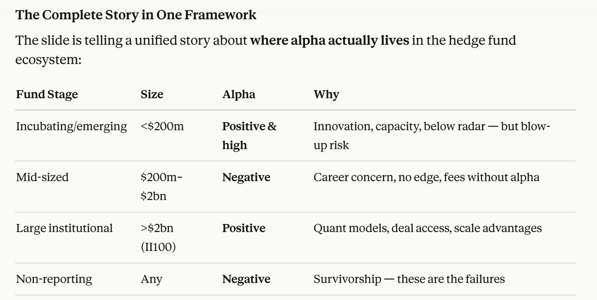
Key Takeaways for Your Exam
1. Alpha is U-shaped, not monotonic. Bigger is not better, but neither is smaller always better. The sweet spots are the extremes, for fundamentally different reasons.
2. Career concern is the primary explanation for mid-fund underperformance. This is a behavioral, incentive-driven phenomenon — not bad luck or market conditions. It is structural and predictable.
3. Survivorship bias is visually demonstrated. The gap between reporting and non-reporting fund alpha is a direct measurement of the bias that inflates all published hedge fund performance statistics.
4. Alpha sources are qualitatively different at each end. Small fund alpha comes from innovation and capacity advantages. Large fund alpha comes from technology and structural deal access. Neither is available to the middle.
5. This connects the entire course together. The U-shape explains why replication works (middle-fund "alpha" is really just expensive beta), why benchmarking matters (you need different benchmarks for different parts of the distribution), why incentive structures are critical (career concern is an agency problem), and why emerging manager investing is both the highest-return and highest-risk allocation in the hedge fund universe.
Xxxxxxxxxxxxxxxxxxxxxxxxxxxxxxxxxxxxxxxxxxxxxxxxxxxxxxxxxxxxx
The slide presents a chart showing alpha across deciles of hedge funds (from worst to best performers), typically constructed by sorting funds into groups based on performance. The x-axis represents deciles (D01 to D10), while the y-axis represents estimated alpha. The general pattern in the chart suggests that most funds generate alpha close to zero or slightly negative, while only the top deciles show positive alpha. This implies that alpha is highly concentrated among a small subset of managers, rather than broadly distributed across the industry.
However, the annotations on the slide highlight that these observed results are distorted by several biases. First, reporting bias and survivorship bias (highlighted near “Reporting / Non-reporting” and “UBS”) imply that poorly performing funds are less likely to report or may disappear from databases, leading to an overestimation of average alpha. Second, the slide notes that apparent alpha may actually reflect hidden risk exposures, meaning that what appears to be skill may in fact be compensation for taking on systematic or non-linear risks. Third, the presence of quant models and increased data access suggests that many traditional sources of alpha have been arbitraged away over time.
The annotations also emphasise that true alpha is rare, often found only among innovative or niche strategies, and that the majority of funds may not generate persistent outperformance. The reference to William Fung and David Hsieh highlights their work showing that much of hedge fund returns can be explained by factor exposures rather than pure alpha. Finally, the mention of “career concerns” suggests that managers may take risks or mimic strategies to protect their reputation, further reducing true alpha generation.
{Memory}
Alpha reality:
- Most funds → ~0 or negative
- Few funds → positive alpha
BUT data is biased:
- Survivorship bias
- Reporting bias
Key insight:
- Alpha ≠ skill
- Often = hidden risk
Industry trend:
- Alpha ↓ over time
- Competition ↑

Conclusion
The distribution of hedge fund alpha suggests that true skill is rare and highly concentrated, but even this may be overstated due to biases and the mismeasurement of risk, implying that much of reported alpha reflects compensation for hidden exposures rather than genuine managerial ability.

#9 Flow/ Performance
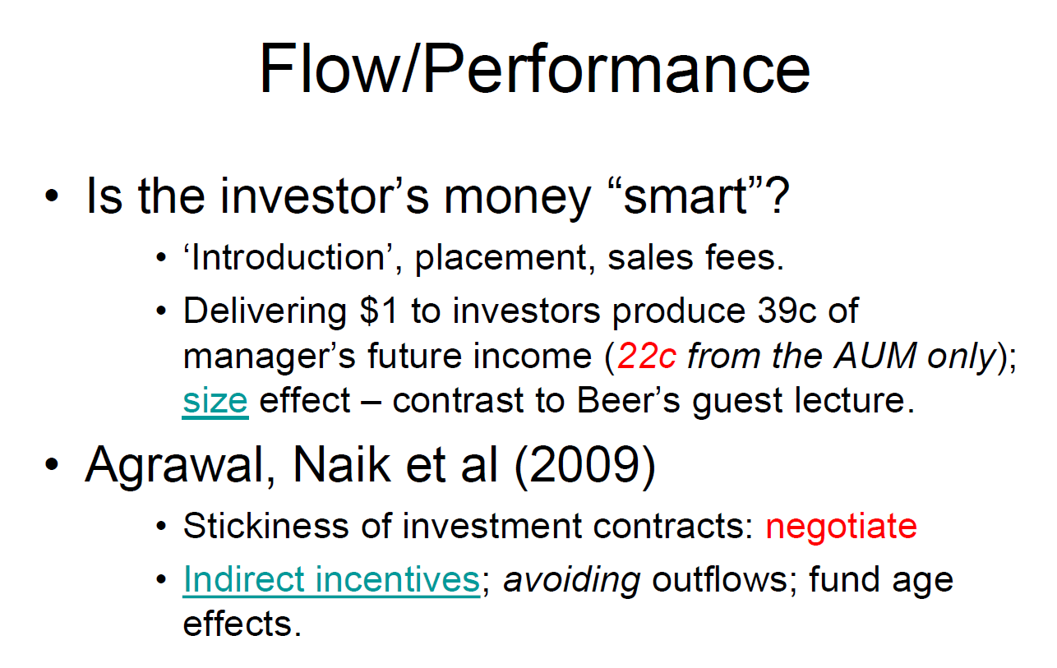
#9.1 Summary
The slide is titled "Flow/Performance" and centers on two interconnected questions: whether investor capital in hedge funds is "smart money" (i.e., does it flow rationally toward skilled managers?), and how the flow-performance relationship creates powerful indirect incentives for managers that dwarf the direct incentives from explicit performance fees.
The Core Question: Is Investor Money "Smart"?
The slide opens with this deliberately provocative question. It touches on the introduction fees, placement fees, and sales fees that intermediaries charge — hinting that capital may flow to funds not purely on merit but partly through distribution relationships and marketing. This is the cynical framing: money may flow toward funds with good salespeople, not just good returns.
The Key Quantitative Finding: The 39-Cent Number
The most important empirical result on the slide comes from Lim, Sensoy and Weisbach (2016) — the Indirect Incentives paper you've been given. The slide states: "Delivering $1 to investors produces 39c of manager's future income (22c from the AUM only)". This is the headline finding of the paper. Breaking it down: for every $1 of incremental return delivered to investors, the manager's expected lifetime income increases by at least 39 cents in total — 16 cents from direct incentives (incentive fees + personal stake) and at least 23 cents from indirect incentives (future fees earned on increased AUM from new inflows). Of that 23 cents, roughly 22 cents comes purely from the management fee on expanded AUM, not even counting performance fees on new money. The slide also references a "size effect" and contrasts this with "Beer's guest lecture" — suggesting a visiting practitioner made a different argument about how fund size affects manager compensation, which the academic evidence here challenges.
Agarwal, Naik et al. (2009) — Three Key Findings
The slide references three specific findings from this paper: the stickiness of investment contracts (fee terms don't change even when they should, creating a "negotiate" opportunity for investors who push back), indirect incentives as a primary driver of manager behavior, avoiding outflows as a key manager priority, and fund age effects — indirect incentives are dramatically stronger for young funds and decline as funds age and become "known quantities."
xxxxxxxxxxxxxxxxxxxxxxxxxxxxxxxxxxxxx
The slide examines the relationship between investor capital flows and hedge fund performance, questioning whether investor money is truly “smart” in allocating capital efficiently. It highlights that investor decisions are influenced not only by performance but also by intermediation frictions, such as introduction, placement, and sales fees, which can distort capital allocation. A key insight is that generating $1 of returns for investors can produce a much larger stream of future income for managers (e.g. 39 cents, with 22 cents driven purely by AUM growth), illustrating the importance of the size effect, where fund growth generates persistent fee income regardless of future performance.
The slide also draws on the work of Agarwal, Narayan Naik et al. (2009), which shows that hedge fund investment contracts exhibit stickiness, meaning investors do not rapidly withdraw capital even after poor performance. This is due to a combination of contractual constraints, behavioural biases, and indirect incentives faced by managers, such as avoiding outflows and maintaining AUM. The slide further highlights indirect incentives, where managers may prioritise strategies that reduce volatility or avoid large drawdowns to retain investor capital, rather than maximising pure alpha. Additionally, fund age effects suggest that investor behaviour and flow sensitivity differ across the lifecycle of a fund, with younger funds attracting inflows based on performance, while older funds benefit from more stable capital.
Overall, the slide suggests that capital flows in hedge funds are not perfectly efficient, and that both manager incentives and investor behaviour play a significant role in determining how capital is allocated across funds.
{Memory}
> Are investors “smart”?
- Partly
- BUT biased + constrained
> Key concepts:
- Performance chasing
- Stickiness
- Size effect
> Manager behaviour:
- Avoid outflows
- Grow AUM
- Not always maximise alpha
Conclusion
Hedge fund capital flows are only partially efficient, as they are shaped not only by performance but also by contractual frictions, behavioural biases, and managerial incentives linked to asset growth.

AI Prompt
Hi I am having hedge fund exam tomorrow and the attached slide is part of the exam curriculum. Can you first summarize the slide (describe the chart in it), then can you generate top two exam questions that will most likely appear in the exam (to examine the slide’s information and materials)? Please provide the best answers (in paragraph format) to address the questions so that I can score 20 mark over 20 mark. I attached all the resources, research, website links in this powerpoint slide here for your reference. Please read them all and digest and give me the best summary of the slide. Imagine you are my hedge fund professor, what will you ask me in the exam? Please provide the best and accurate 3 exam questions & answers related to this slide.

